TEAM 1-K15T1-VANLANGUNI
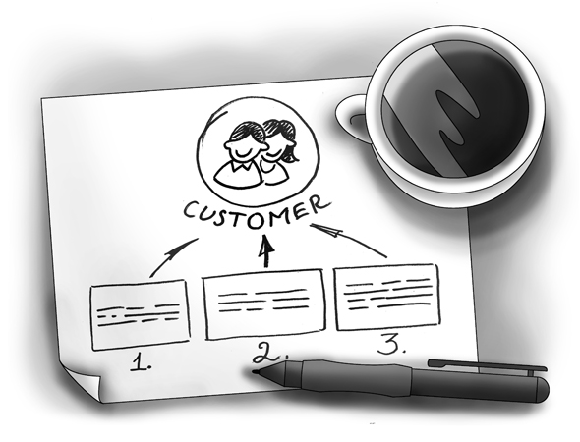
SOFTWARE REQUIREMENT SPECIFICATION
Meeting Room Booking System (MRBS)
Ver0.1
Prepared by: Team 1-K15T1-Vanlanguni
12/6/12

Team Members:
- Le Dinh Thach Huyen (Member)
- Dang Huy Son (Technical Researcher)
- Do Minh Tam (Technical Researcher & Recorder)
- Nguyen Trung Tin (Member)
- Dang Nguyen Toan (Member)
- Le Thi Bich Van (Project Manager)
Abstract:
Meeting Room Booking System is program manages the room meeting, statistic and report for IT faculty department of Van Lang University. This document describes the requirements for the Room Meeting Booking System product
Revision History
Content | Date | Author | Version
Define template and main contents | 6/12/12 | Van Le | Ver0.1
Update template and main contents | 6/16/12 | Tam Do | Ver1.0
Update content draft | 6/17/12 | Tam Do | Ver1.1
Update content UC diagram and UC description of Tam Do into SRS | 6/20/12  7/1/12 | Huyen Le | Ver1.2  Ver 1.3
 | 7/2/12 | Van Le | Ver1.4
 | 7/2/12 | Huyen Le | Ver1.5

Table of contents
1. Introduction 4
1.1. Purpose 4
1.2. Scope 4
1.3. Information of stakeholder for MRBS project 4
1.3.1. The customer for MRBS project 4
1.3.2. The Suppervisor for MRBS project 4
1.3.3. Our team for the project is called Team 1-K15T1-Vanlanguni and consists of 5
1.4. Definition and Acronyms 5
1.5. References 5
2. The Existing Logical System 6
3. The Proposed Logical System 6
4. System Overview 6
4.1. Product Perspective 6
4.2. User Analysis and Characteristics 6
4.3. Product Feature 7
4.4. Operating Environment 8
5. Specific Requirement 8
5.1. External Interface Requirement 8
5.1.1. User Interfaces 8
5.2. System Features 9
5.2.1. Usecase Diagram 9
5.3. Software Quality Attributes 10
5.3.1. Performance Requirements 10
5.3.2. Usability Requirements 10
5.3.3. Other Requirements 10
6. Appendix 1 10

List of figure
Figure4. 3. 1 - Requirement Breakdown Structure 8

Figure 5.1.1.1. 1 - User Interfaces Architecture 9

Figure 5.2.1. 1 - Usecase Diagram Level 1 10

List of table
Table 1. 4. 1 7

Table 4 .2 .1 7

Table 5.2.1. 1 - Usecase Description Level 1 10

Introduction
This document formally states the requirements for the RMBS product.

Purpose
The SRS document created by the team 11 provides both the functional and non-functional requirements of the Meeting Room Booking System (MRBS). This document includes definitions, specifications, and other information that will be helpful for the customer and for the team 11 to have a clear understanding of the system to be developed.
From this document, the customer will be able to understand our team’s comprehension of the requirements. This document can be updated or revised when required by the customer as we consider our customer’s demands important for our project. This document will evolve according to the requirement.

Scope of project
These requirements have been priority into three levels:
  - Essential
The minimum set of requirements for the product to be accepted.
  - Highly Desirable
Requirements that are considered to be likely inclusions to the product, time permitting.
  - Desirable
Requirements that are not likely to be added in this version, but should be considered for future modifications.
MRBS will help the faculty officer manages the meeting room, statistic and report for IT faculty department, use for one branch, one computer and use bar code

Information of stakeholder for MRBS project

The customer for MRBS project
Mr. Nam Vu, Teacher of Van Lang University
Phone: 0903308809
E–Mail: mailto:vuthenam@vanlanguni.edu.vn

The Suppervisor for MRBS project

Mr. Nam Vu, Teacher of Van Lang University
Phone: 090.330.8809
E–Mail: mailto:vuthenam@vanlanguni.edu.vn
Mr. Phung Bui, Teacher of Van Lang University
Phone: 090.999.7556
E–Mail: mailto:buiminhphung@vanlanguni.edu.vn

Mr. Thanh Vo, Mentor for Project Team
Phone: 090.240.5778
E–Mail: mailto:vnthanh25@gmail.com

Our team for the project is called Team 1-K15T1-Vanlanguni and consists of

Le Dinh Thach Huyen, Member
Phone: 090.918.8571
E–Mail: mailto:radinkasim@gmail.com

Dang Huy Son, Technical Researcher
Phone: 0199.8766.424
E–Mail: mailto:slavril.2009@gmail.com

Do Minh Tam, Technical Researcher & Recorder
Phone: 0126.7322.839
E–Mail: mailto:tamdo4@gmail.com
Nguyen Trung Tin, Member
Phone: 0128.4317.131
E–Mail: mailto:trungtin119@gmail.com

Dang Nguyen Toan, Member
Phone: 093.768.2000
E–Mail: mailto:dangtrannguyentoan@gmail.com
Le Thi Bich Van, Project Manager
Phone: 0985197070
E–Mail: vanbichthile@gmail.com, vanle12@vanlanguni.vn

Definition and Acronyms
No. | Term | Definition
1. | MRBS | Meeting Room Booking System
2. | SRS | Software Requirement Specification
3. | GUI | Graphical User Interface
4. | CMU | Carnegie Mellon University
5. | FC | Function
6. | FT | Feature
Table 1. 4. 1

References
HPIMS_SRS_v1.03.doc of CMU

The Existing Logical System
The client has no existing system for RMBS

The Proposed Logical System
- As this is only a suggestion for the proposed logical system, all requirements mentioned in this section
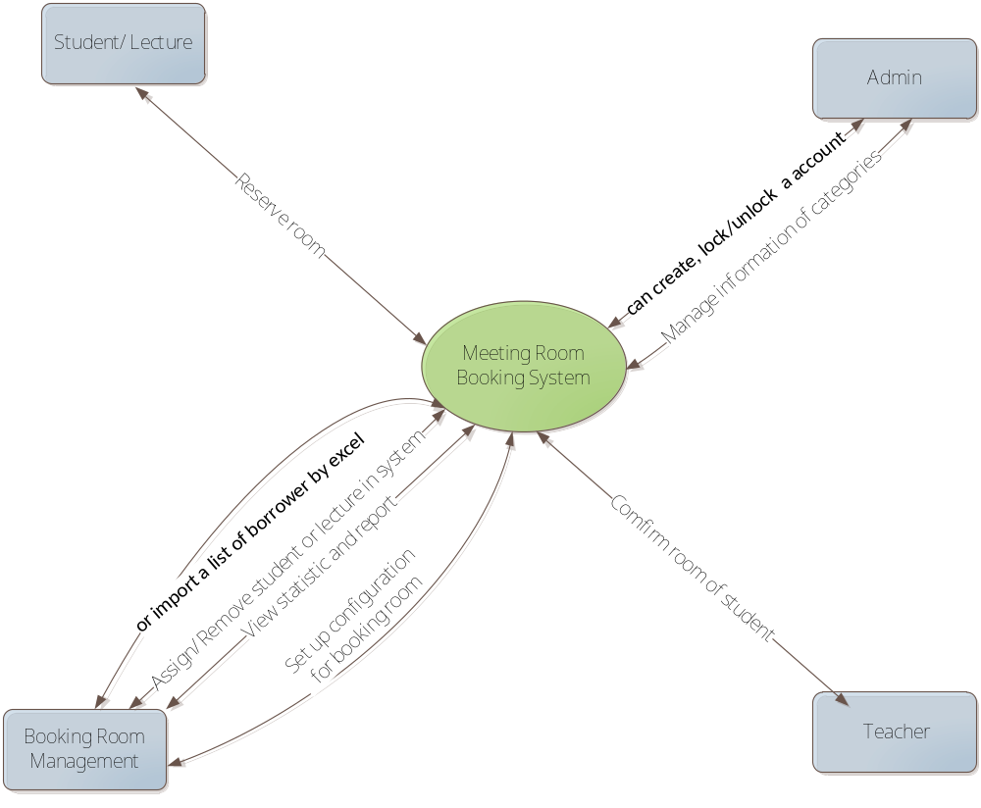
- System Environment
- The system was built and developed through C#.
- Application server:
- Windows OS server -2003 or Windows OS server -2008
- CPU Core 2 dual or Xeon 4 core.
- DatabaseMSSQL Server 2008
- Client:
- Windows XP - OS or Window 7
- CPU Pentium IV, 1.2 GHz or core 2 dual.
- Memory RAM 1GB

System Overview

Product Perspective
MRBS is aimed toward a person who has considerable number of registry meeting room in IT department, and so needs software assistance for book meeting room and computations regarding the priority. MRBS should be user friendly, quick to learn and reliable software for above purpose

User Analysis and Characteristics
The two primary actors in MRBS are user (Faculty Officer) and Administrator
No. | Actor | Description
1. | Administrator | Administrator shall set the right to use MRBS system
2. | Faculty Officer | Faculty Officer shall manage account, borrower, room borrow, static and report, room, floor, setting system. And the faculty officer shall send out notifications through an automated email to borrower
Table 4 .2 .1

Product Feature
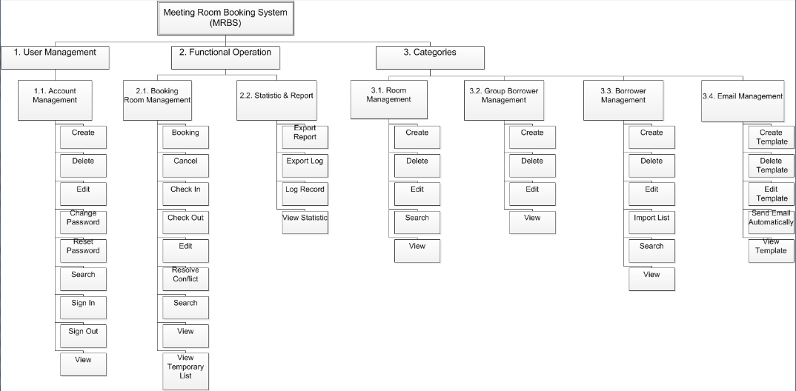
Figure4. 3. 1 - Requirement Breakdown Structure
MRBS should support the following feature:
- Account Management – Create, View, Edit, Search, Lock/Unlock, Sign In, Sign Out
  - User can create a new account, view information about the account, edit MRBS password an existing account, search, lock/unlock account, and sign in/sign out MRBS.
- Borrower Management
  - User can create a new borrower, or import a list of borrower by excel (*.xls), view, edit or search information about the borrower.
- Room Borrow Management
  - User can register a meeting room, check in/check out for borrower, change, search information about meeting room or approve/reject every request to borrow meeting room.
- Statistic and Report
  - User can view report about the meeting room, borrower violation, …
- Room Management
  - User can create a new room, and view, edit or search information about the room.
- Setting – Priority, Email
  - This feature is used to set automatic priority when register the meeting room for borrower. It may be set template and send automatic email.

Operating Environment
The target system is a standalone application in a PC environment on Microsoft Windows XP, 7 with Microsoft SQL Server 2008.
The system will be developed using platform-independent C# language.

Specific Requirement

External Interface Requirement

User Interfaces
This user interface is prototype made after discussion among team 11. This will help the client to see the user interface of our final program artifact in this project. The contents and appearance can be changed or refined based on the user’s requirement and technical constraints.

User Interfaces Architecture
This is the overall architecture of MRBS prototypical user interface. The user interface is divided into three, mainly based on the functions of MRBS.
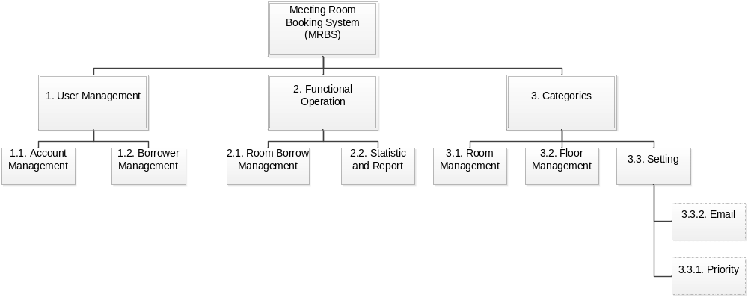
Figure 5.1.1.1. 1 - User Interfaces Architecture

System Features

Actor Table
Name | Responsibility | Role
Administrator | Administrator is a | Administrator
Booking Borrower | Booking Borrower is a | Officer Administrator

Usecase Diagram
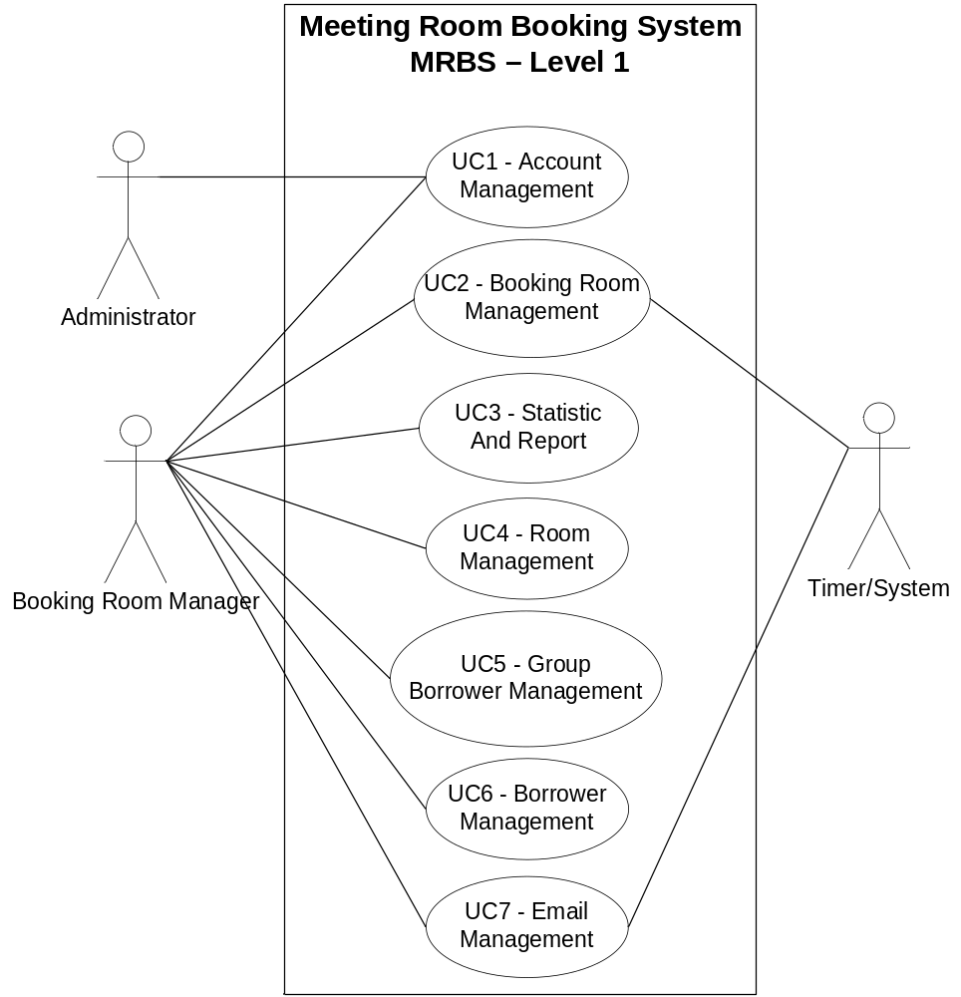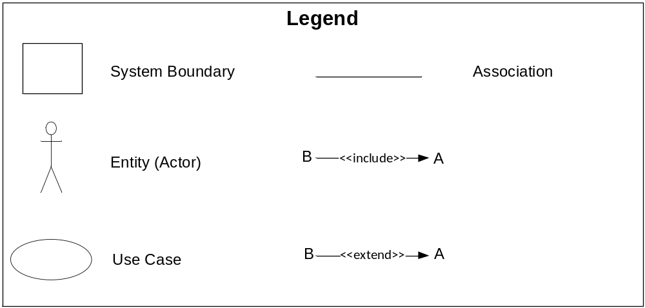 Figure 5.2.1. 1 - Usecase Diagram Level 1
      - Account Management
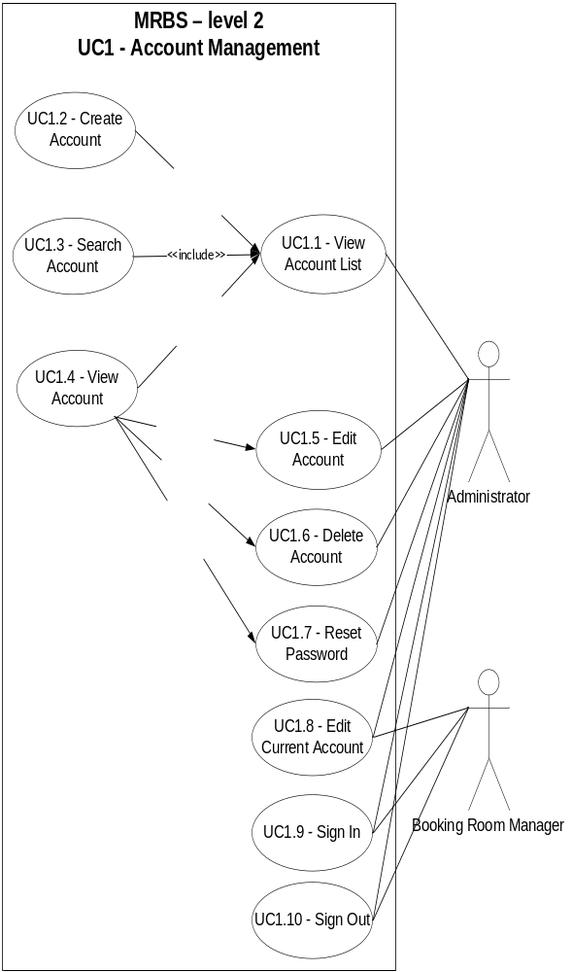
      - Booking Room Management
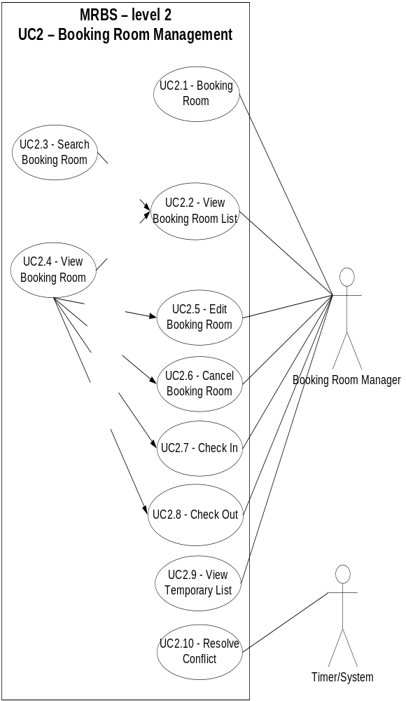
      - Statistic And Report
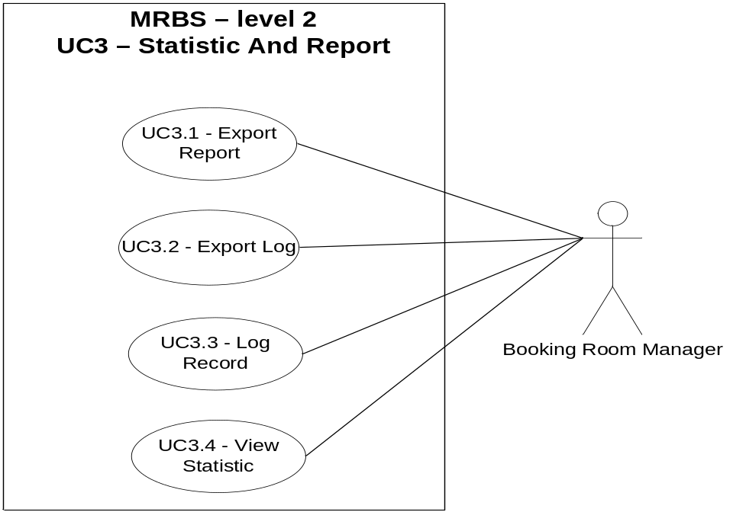
      - Room Management
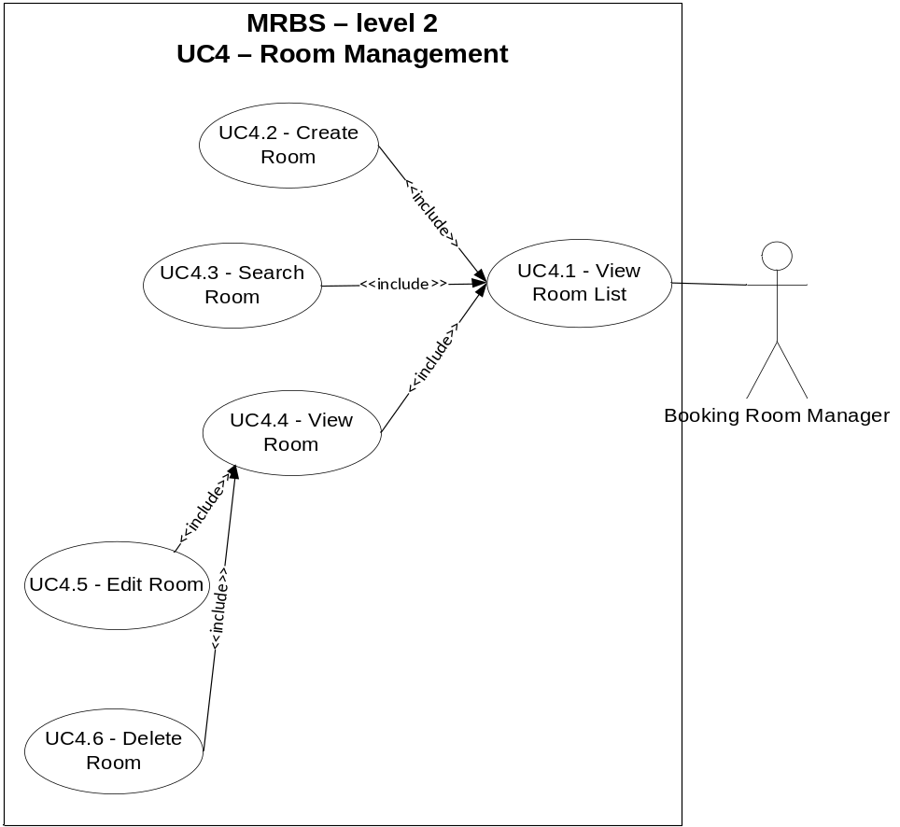
      - Group Borrower Management
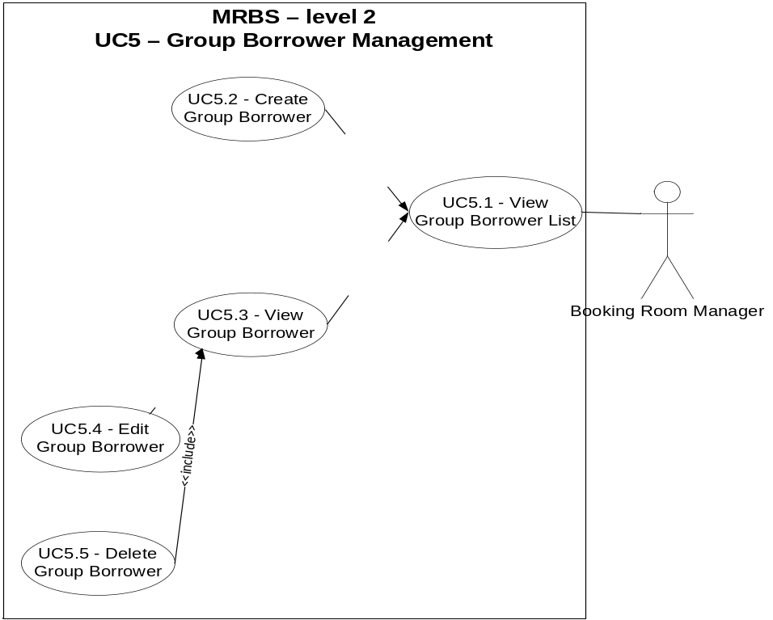
      - Borrower Management
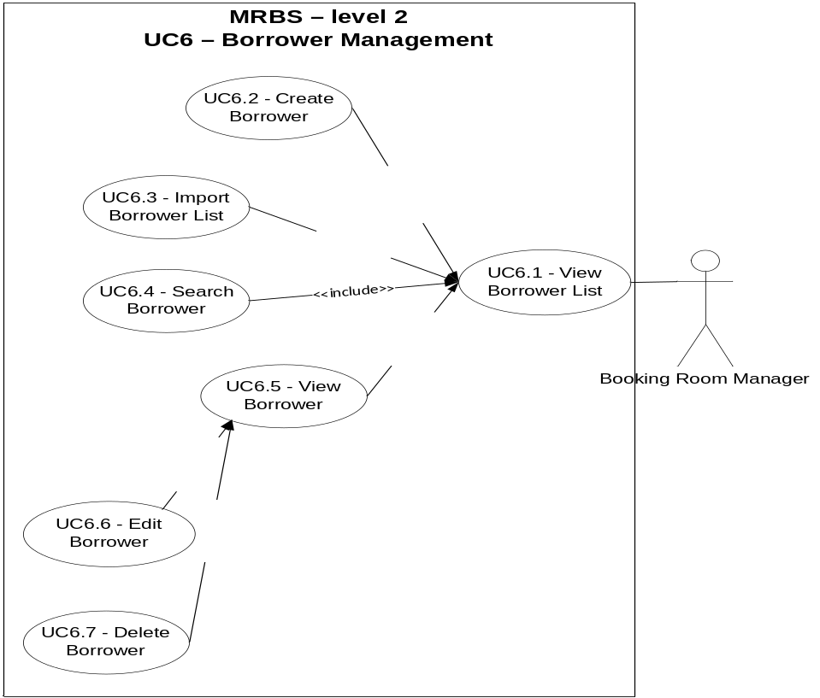
      - Email Management
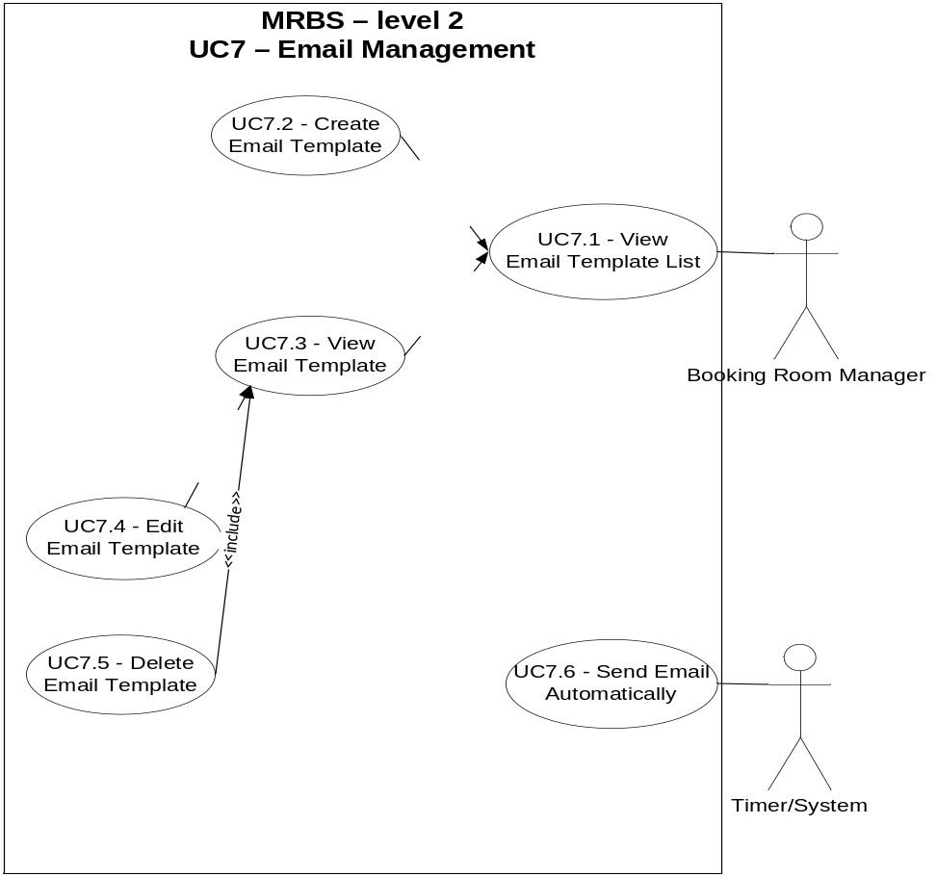
      - Recycle Bin Management
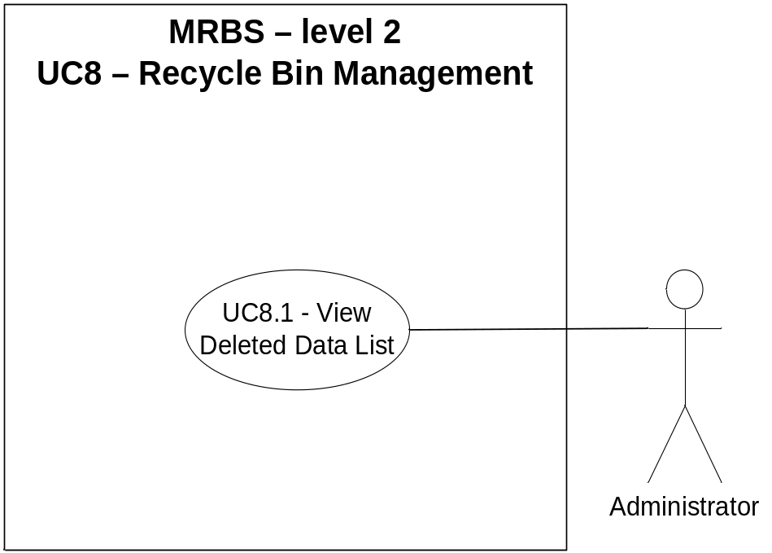
    - Use-case Table
Use Case ID | Use Cases Name | Primary Actor
UC1 | Account Management | Administrator
UC1.1 | View Account List
UC1.2 | Create Account
UC1.3 | Search Account
UC1.4 | View Account
UC1.5 | Edit Account
UC1.6 | Delete Account
UC1.7 | Reset Password
UC1.8 | Reset Admin’s Password
UC1.9 | Edit Current Account
UC1.10 | View Current Account
UC1.11 | Sign In
UC1.12 | Sign Out
UC2 | Booking Room Management | Booking Room Manager
UC2.1 | Booking Room
UC2.2 | View Booking Room List
UC2.3 | Search Booking Room
UC2.4 | View Booking Room
UC2.5 | Change Booking Room
UC2.6 | Cancel Booking Room
UC2.7 | Check In
UC2.8 | Check Out
UC2.9 | View Conflict List
UC2.10 | Resolve Conflict
UC2.11 | Resolve Conflict Automatically
UC3 | Statistic And Report | Booking Room Manager
UC3.1 | Export Report
UC3.2 | View Statistic
UC3.3 | Log Record
UC4 | Room Management | Booking Room Manager
UC4.1 | View Room List
UC4.2 | Create Room
UC4.3 | Search Room
UC4.4 | View Room
UC4.5 | Edit Room
UC4.6 | Delete Room
UC5. | Group Borrower Management | Booking Room Manager
UC5.1 | View Group Borrower List
UC5.2 | Create Group Borrower
UC5.3 | View Group Borrower
UC5.4 | Edit Group Borrower
UC5.5 | Delete Group Borrower
UC6. | Borrower Management | Booking Room Manager
UC6.1 | View Borrower List
UC6.2 | Create Borrower
UC6.3 | Import Borrower List
UC6.4 | Search Borrower
UC6.5 | View Borrower
UC6.6 | Edit Borrower
UC6.7 | Edit Violation
UC6.8 | Delete Borrower
UC6.9 | View Violation List
UC7 | Email Management | Booking Room Manager
UC7.1 | View Email Template List
UC7.2 | View Email Template
UC7.3 | Edit Email Template
UC7.4 | View Resend Email List
UC7.5 | Send Email Automatically
UC7.6 | Resend Email Automatically
UC8 | Recycle Bin Management | Administrator
UC8.1 | View Deleted Data List
Table 5.2.1. 1 – Use-case Description Level 1
    - Use-case Description
For more information, view file

Software Quality Attribute
ID | Quality Attribute Description
QA01 | Quality attribute: Performance  The program create report quickly, time is less than 5s.
QA02 | Quality attribute: Availability  System should provide availability with very small downtime periods.
QA03 | Quality attribute: Security  Password must be encrypted
QA04 | Quality attribute: Usability  The application easy to using the booking room function.

Performance Requirements
- Load students and lecturers list: When user send request to view the student or lecturers list, program should be loaded in 5 seconds
- Perform statistical report: When user send request to perform statistical report, program must be processed and showed in 10 seconds
- System can handle 5 requests in 30 seconds
Portion of scenario | Possible values
ID: 01 | Performance
Source | Users
Stimulate | View list, statistic, execute request
Artifact | Student/ lecture list
Environment | Normally
Response | Must be loaded and system still working
Response Measure | In 5 seconds

Usability Requirements
- Easy to use program: System support and provides everything for the user to easily implement the system and accomplish a task of user
Portion of scenario | Possible values
ID: 02 | Usability
Source | User
Stimulate | Interact Interface
Artifact | GUI
Environment | Normally
Response | GUI is easy for user to interact
Response Measure | No

Other Requirements

Constraint Table
BC ID | Description | Difficulty  Ranking | Comments
BC.01 | Product is released on 08/10/2012 with full features that customer need | 1 | Project team can hardly implement because no much experience
BC.02 | Project is developed by the team with 5 members, ready to develop more features. Products are maintained for 3 years | 2 | Project team can hardly implement because no much experience

Business rule
ID | Description
BR1.2.01 | Required field not accept null: “Tên tài khoản”; “Họ tên”; “Email”
BR1.2.02 | “Tên tài khoản” not accept more than 15 characters and space between them; accept characters and numeric only
BR1.2.03 | “Họ tên” not accept more than 50 characters; accept characters and numeric, can use Vietnamese language
BR1.2.04 | “SDT” not accept more than 10 characters; accept numeric only
BR1.2.05 | “Email” not accept more than 25 characters and space between them; must follow standard of email address (ex: @abc.xyz)
BR1.2.06 | “Email” not exist in database
BR1.3.01 | “Tìm kiếm phòng” not accept more than 10 characters; accept characters and numeric only
BR1.5.01 | Required field not accept null: “Họ tên”; “Email”
BR1.5.02 | “Họ tên” not accept more than 50 characters; accept characters and numeric, can use Vietnamese language
BR1.5.03 | “SDT” not accept more than 10 characters; accept numeric only
BR1.5.04 | “Email” not accept more than 25 characters and space between them; must follow standard of email address (ex: @abc.xyz)
BR1.5.05 | “Email” not exist in database
BR1.6.01 | Not delete information in database, system just change the status of that information that user choose to delete into “Đã xóa” in database
BR1.10.01 | Required field not accept null: “Mật khẩu cũ”; “Mật khẩu mới”; “Lặp lại mật khẩu mới”
BR1.10.02 | “Mật khẩu mới” và “Lặp lại mật khẩu mới” phải giống nhau
BR1.11.01 | Required field not accept null: “Tài khoản”; “Mật khẩu”
BR1.11.02 | “Tài khoản” must exist in database
BR1.11.03 | “Mật khẩu” must correct with “Mật khẩu” of account
BR4.2.01 | Required field not accept null: “Tên phòng”
BR4.2.02 | “Tên phòng” not accept more than 10 characters and space between them; accept characters and numeric only
BR4.2.03 | “Sức chứa” not accept more than 5 characters and space between them; accept numeric only
BR4.2.04 | “Tên phòng” not exist in database
BR4.3.01 | “Tìm kiếm phòng” not accept more than 10 characters; accept characters and numeric only
BR4.5.01 | User can edit field: “Sức chứa”
BR4.5.02 | “Sức chứa” not accept more than 5 characters and space between them; accept numeric only
BR4.6.01 | Not delete information in database, system just change the status of that information that user choose to delete into “Đã xóa” in database
BR5.2.01 | Required field not accept null: “Mã nhóm”; “Tên nhóm”
BR5.2.02 | “Tên nhóm” not accept more than 20 characters; accept characters and numeric only, can use Vietnamese language
BR5.4.01 | User can edit field: “Tên nhóm”
BR5.4.02 | Required field not accept null: “Mã nhóm”; “Tên nhóm”
BR5.4.03 | “Tên nhóm” not accept more than 20 characters; accept characters and numeric only, can use Vietnamese language
BR5.5.01 | Not delete information in database, system just change the status of that information that user choose to delete into “Đã xóa” in database
BR6.2.01 | Required field not accept null: “Tên nhóm”; “Mã người mượn”; “Họ tên”;“Email”
BR6.2.02 | “Mã người mượn” not accept more than 20 characters and space between them; accept characters and numeric only
BR6.2.03 | “Họ tên” not accept more than 50 characters; accept characters and numeric, can use Vietnamese language
BR6.2.04 | “Email” not accept more than 25 characters and space between them; must follow standard of email address (ex: @abc.xyz)
BR6.2.05 | “Mã người mượn” not exist in database
BR6.2.06 | “Email” not exist in database
BR6.3.01 | Required field not accept null: “Tên nhóm”; “Mã người mượn”; “Họ tên”; “Email”
BR6.3.02 | “Mã người mượn” not accept more than 20 characters and space between them; accept characters and numeric only
BR6.3.03 | “Họ tên” not accept more than 50 characters; accept characters and numeric, can use Vietnamese language
BR6.3.04 | “Email” not accept more than 25 characters and space between them; must follow standard of email address (ex: @abc.xyz)
BR6.3.05 | “Mã người mượn” has existed in database
BR6.3.06 | “Email” has existed in database
BR6.4.01 | “Tìm kiếm phòng” not accept more than 50 characters; accept characters and numeric, can use Vietnamese language
BR6.6.01 | User can edit field: “Tên nhóm”; “Mã người mượn”; “Họ tên”; “SDT”; “Email”
BR6.6.02 | Required field not accept null: “Tên nhóm”; “Mã người mượn”; “Họ tên”; “Email”
BR6.6.03 | “Họ tên” not accept more than 50 characters; accept characters and numeric, can use Vietnamese language
BR6.6.04 | “Email” not accept more than 25 characters and space between them; must follow standard of email address (ex: @abc.xyz)
BR6.6.05 | “Email” not exist in database (except old email)
BR6.8.01 | Not delete information in database, system just change the status of that information that user choose to delete into “Đã xóa” in database
BR7.3.01 | User can edit field: “Tiêu đề”; “Nội dung”; “Áp dụng mẫu này”
BR7.3.02 | Required field not accept null: “Tiêu đề”; “Nội dung”
BR7.3.03 | “Tiêu đề” not accept more than 100 characters; accept characters and numeric, can use Vietnamese language
BR7.3.04 | “Nội dung” not accept more than 1000 characters; accept characters and numeric, can use Vietnamese language

Acceptance Criteria
The acceptance criteria for the product are defined by all Level 1 requirements. That is, Level 1 contains the minimum requirements that have to be met for the project to be accepted. Levels 2 and 3 represent likely and future inclusions respectively, the feasibility of which will be determined during the project.
Note that Level 1 requirements may not necessarily be implemented if they are replaced by corresponding Level 2 or 3 requirements.

Appendix 1
Name | File
Use Case Description

